**Aim:- Packet Tracer - Configure Cisco Routers for Syslog , NTP, and SSH Operations**

**Part 1: Configure OSPF MD5 Authentication**

**Step 1: Test connectivity. All devices should be able to ping all other IP addresses.**

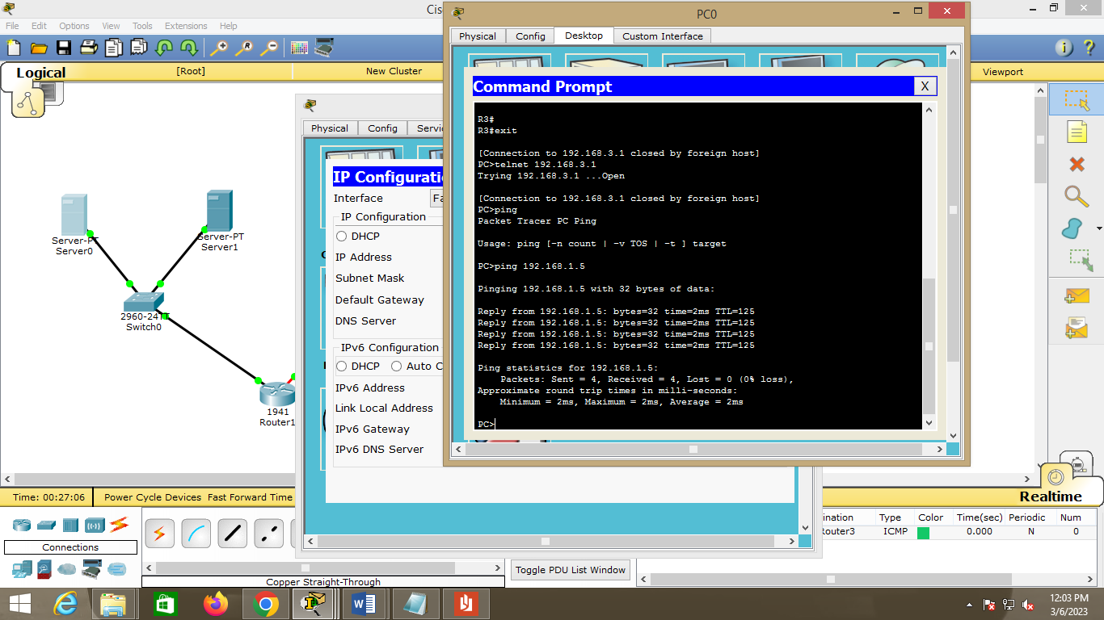

**Step 2: Configure OSPF MD5 authentication for all the routers in area 0.**

Configure

OSPF MD5 authentication for all the routers in area 0.

R1(config)# **router ospf 1**

R1(config-router)# **area 0 authentication message-digest**

R2(config)# **router ospf 1**

R2(config-router)# **area 0 authentication message-digest**

R3(config)# **router ospf 1**

R3(config-router)# **area 0 authentication message-digest**

**Step 3: Configure the MD5 key for all the routers in area 0.**

Configure an MD5 key on the serial

interfaces on **R1**, **R2** and **R3**. Use the password **MD5pa55** for key **1**.

R1(config)# **interface s0/0/0**

R1(config-if)# **ip ospf message-digest-key 1 md5 MD5pa55**

R2(config)# **interface s0/0/0**

R2(config-if)# **ip ospf message-digest-key 1 md5 MD5pa55**

R2(config-if)# **interface s0/0/1**

R2(config-if)# **ip ospf message-digest-key 1 md5 MD5pa55**

R3(config)# **interface s0/0/1**

R3(config-if)# **ip ospf message-digest-key 1 md5 MD5pa55**

**Step 4: Verify configurations.**

a. Verify the MD5 authentication configurations using the commands **show ip ospf interface**.

b. Verify end-to-end connectivity.

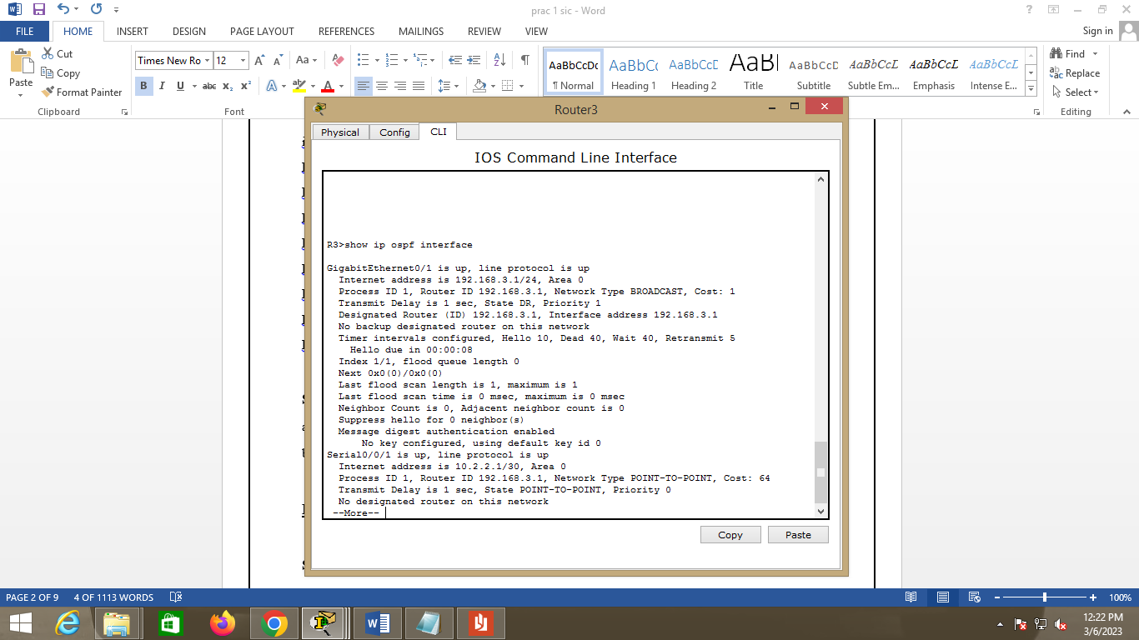

**Part 2: Configure NTP**

**Step 1: Enable NTP authentication on PC-A.**

a. On **PC-A**, click **NTP** under the Services tab to verify NTP service is enabled.

b. To configure NTP authentication, click **Enable** under Authentication. Use key **1** and password **NTPpa55**

for authentication.

**Step 2: Configure R1, R2, and R3 as NTP clients.**

R1(config)# **ntp server 192.168.1.5**

R2(config)# **ntp server 192.168.1.5**

R3(config)# **ntp server 192.168.1.5**

Verify client configuration using the command **show ntp status**.

**Step 3: Configure routers to update hardware clock.**

Configure **R1**, **R2**, **and R3** to periodically

update the hardware clock with the time learned from NTP.

R1(config)# **ntp update-calendar**

R2(config)# **ntp update-calendar**

R3(config)# **ntp update-calendar**

Exit global configuration and verify that the hardware clock was updated using the command **show clock**.

**Step 4: Configure NTP authentication on the routers.**

Configure NTP

authentication on **R1**, **R2**, and **R3** using key **1** and password **NTPpa55**.

R1(config)# **ntp authenticate**

R1(config)# **ntp trusted-key 1**

R1(config)# **ntp authentication-key 1 md5 NTPpa55**

R2(config)# **ntp authenticate**

R2(config)# **ntp trusted-key 1**

R2(config)# **ntp authentication-key 1 md5 NTPpa55**

R3(config)# **ntp authenticate**

R3(config)# **ntp trusted-key 1**

R3(config)# **ntp authentication-key 1 md5 NTPpa55**

**Step 5: Configure routers to timestamp log messages.**

Configure timestamp service for logging on the routers.

R1(config)# **service timestamps log datetime msec**

R2(config)# **service timestamps log datetime msec**

R3(config)# **service timestamps log datetime msec**

**Part 3: Configure Routers to Log Messages to the Syslog Server**

**Step 1: Configure the routers to identify the remote host (Syslog Server) that will receive**

**logging messages.**

R1(config)# **logging host 192.168.1.6**

R2(config)# **logging host 192.168.1.6**

R3(config)# **logging host 192.168.1.6**

The router console will display a message that logging has started.

**Step 2: Verify logging configuration.**

Use the command **show logging** to verify logging has been enabled.

**Step 3: Examine logs of the Syslog Server.**

From the **Services** tab of the **Syslog Server**’s dialogue box, select the **Syslog** services button. Observe the

logging messages received from the routers.

**Note**: Log messages can be generated on the server by executing commands on the router. For example,

entering and exiting global configuration mode will generate an informational configuration message. You may

need to click a different service and then click **Syslog** again to refresh the message display.

**Part 4: Configure R3 to Support SSH Connections**

**Step 1: Configure a domain name.**

Configure a

domain name of **ccnasecurity.com** on **R3**.

R3(config)# **ip domain-name ccnasecurity.com**

**Step 2: Configure users for login to the SSH server on R3.**

Create a user ID of **SSHadmin** with the highest possible privilege level and a secret password of

**ciscosshpa55**.

R3(config)# **username SSHadmin privilege 15 secret ciscosshpa55**

**Step 3: Configure the incoming vty lines on R3.**

Use the local user accounts for

mandatory login and validation. Accept only SSH connections.

R3(config)# **line vty 0 4**

R3(config-line)# **login local**

R3(config-line)# **transport input ssh**

**Step 4: Erase existing key pairs on R3.**

Any existing

RSA key pairs should be erased on the router.

R3(config)# **crypto key zeroize rsa**

**Note**: If no keys exist, you might receive this message: % No Signature RSA Keys found in

configuration.

**Step 5: Generate the RSA encryption key pair for R3.**

The router uses the RSA key pair for authentication and encryption of transmitted SSH data. Configure the

RSA keys with a modulus of **1024**. The default is 512, and the range is from 360 to 2048.

R3(config)# **crypto key generate rsa**

The name for the keys will be: R3.ccnasecurity.com

Choose the size of the key modulus in the range of 360 to 2048 for your

General Purpose Keys. Choosing a key modulus greater than 512 may take

a few minutes.

How many bits in the modulus [512]: **1024**

% Generating 1024 bit RSA keys, keys will be non-exportable...[OK]

**Note**: The command to generate RSA encryption key pairs for **R3** in Packet Tracer differs from those used in

the lab.

**Step 6: Verify the SSH configuration.**

Use the **show ip ssh** command to see the current settings. Verify that the authentication timeout and retries

are at their default values of 120 and 3.

**Step 7: Configure SSH timeouts and authentication parameters.**

The default SSH timeouts and authentication parameters can be altered to be more restrictive. Set the

timeout to **90** seconds, the number of authentication retries to **2**, and the version to **2**.

R3(config)# **ip ssh time-out 90**

R3(config)# **ip ssh authentication-retries 2**

R3(config)# **ip ssh version 2**

Issue the **show ip ssh** command again to confirm that the values have been changed.

**Step 8: Attempt to connect to R3 via Telnet from PC-C.**

Open the Desktop of **PC-C**. Select the Command Prompt icon. From **PC-C**, enter the command to connect to

**R3** via Telnet.

PC> **telnet 192.168.3.1**

This connection should fail because **R3** has been configured to accept only SSH connections on the virtual

terminal lines.

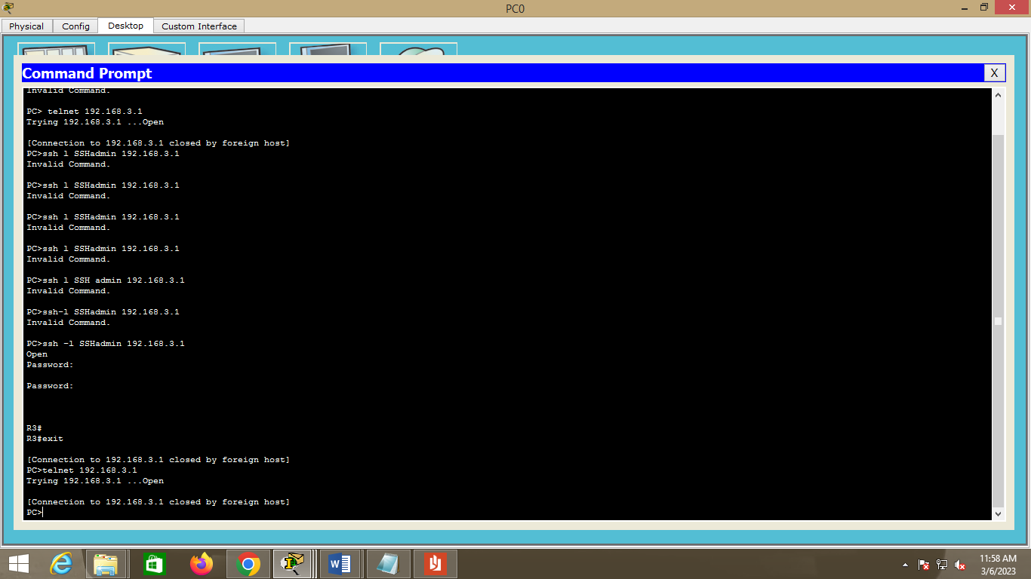

**Step 9: Connect to R3 using SSH on PC-C.**

Open the Desktop of **PC-C**. Select the Command Prompt icon. From **PC-C**, enter the command to connect to

R3 via SSH. When prompted for the password, enter the password configured for the administrator

**ciscosshpa55**.

PC> **ssh –l SSHadmin 192.168.3.1**

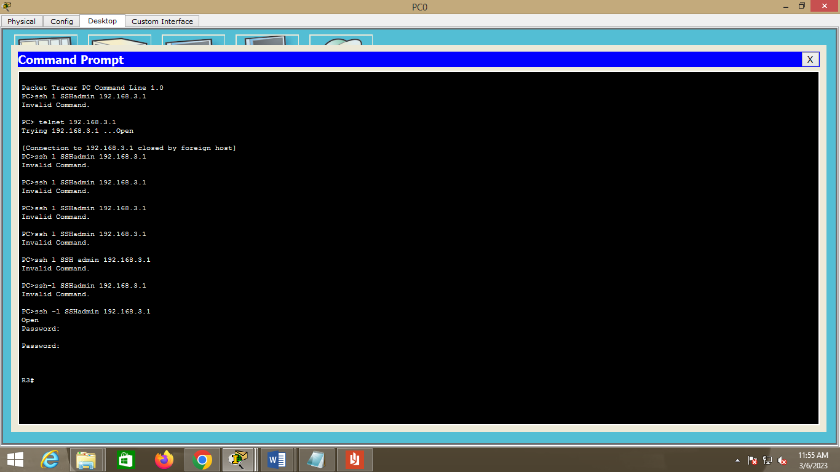

**Step 10: Connect to R3 using SSH on R2.**

To troubleshoot and maintain **R3**, the administrator at the ISP must use SSH to access the router CLI. From

the CLI of **R2**, enter the command to connect to **R3** via SSH version **2** using the **SSHadmin** user account.

When prompted for the password, enter the password configured for the administrator: **ciscosshpa55**.

R2# **ssh –v 2 –l SSHadmin 10.2.2.1**

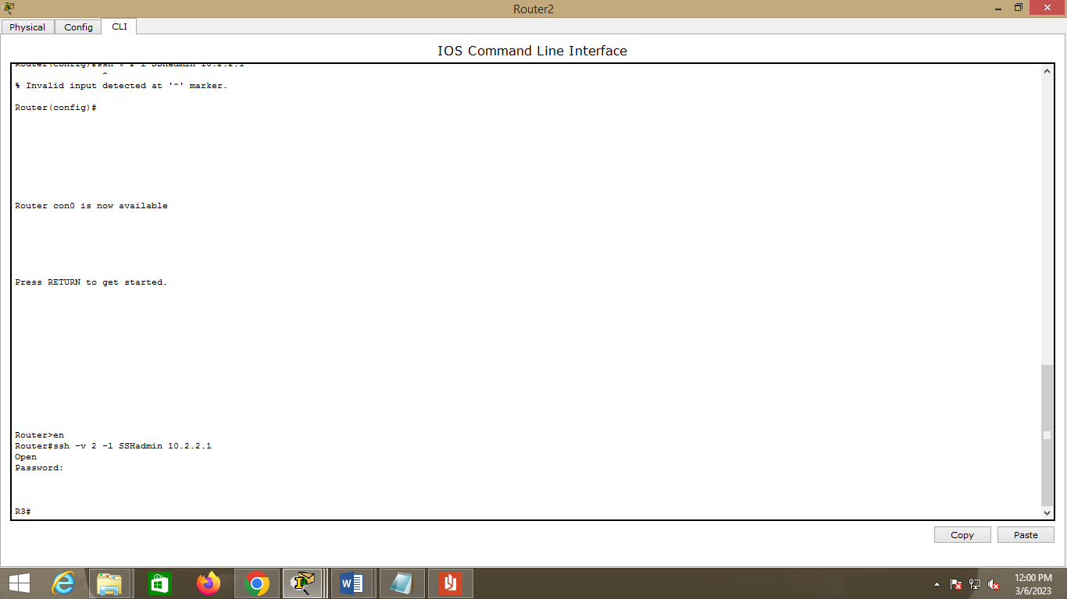

**Step 11: Check results.**

Your completion percentage should be 100%. Click **Check Results** to view the feedback and verification of

which required components have been completed.

OUTPUT:

